A

DISSERTATION

**DESIGN AND DEVELOPMENT OF**

**XY AXIS SKETCHING ROBOT**

By

**(GROUP NO.14)**

|  |  |
| --- | --- |
| **Mr. Shashank Sameer Joshi**  (BMHC03) | **Mr. Dineshkumar Vankhade**  (BMHC) |
| **Mr. Sneha Vitthal Koli**  (BMHC07) | **Mr. Kirtee Pralhad Dubal**  (BMHC11) |

**Guide**

**Dr. Sumit Desai**



**Department of Mechanical Engineering**

**Dr. D. Y. Patil Institute of Technology, Pimpri,**

**Pune -411 018**

**[2020 - 2021]**

**Dr. D. Y. Patil Institute of Technology, Pimpri, Pune -411018.**

**Department of Mechanical Engineering**



**C E R T I F I C A T E**

This is to certify that the *Mr. Shashank Joshi, Mr. Dineshkumar Vankhade, Ms. Sneha Koli, Ms. Kirtee Dubal has* successfully completed the Project stage-1 entitled ***“Design and Development of XY Axis Sketching Robot* ”** under my supervision, in the partial fulfilment of Bachelor of Engineering - Mechanical Engineering of Savitribai Phule Pune University during the academic year 2022-2022.

Date:

Place: Pune

Dr. Sumit Desai ________________

Guide External Examiner

Dr.K. K. Dhande Dr. Pramod D. Patil

Head of Department Principal

Dr. D.Y. Patil Instt of Tech. Dr. D.Y. Patil Instt of Tech.

Pimpri, Pune Pimpri, Pune

Seal

**Acknowledgement**

We express our sincere thanks to our guide **Dr. Sumit Desai**, for her constant encouragement and support throughout our B.E project, especially for the useful suggestion given during the course of the project period and having laid down the foundation for the success of this work.

We would like to thank our project coordinator for his assistance, genuine support and guidance from early stages of the project.

We would like to thank Dr. K. K. Dhande, Head of Mechanical Engineering Department for his unwavering support during the entire course of this project work.

We are very grateful to our principal Dr. Pramod D. Patil for providing us with a positive environment.

We also thank to our staff members of our college and technicians for their help in making this project a success. Finally, we take this opportunity to extend our deep appreciation to our family and friends, for all they meet to us during the crucial times of the completion of our project.

Mr. Shashank Joshi

Mr.Dineshkumar Vankhade

Ms. Sneha Koli

Ms. Kirtee Dubal

**Contents**

|  |  |  |  |
| --- | --- | --- | --- |
| **Sr. No.** | **Topic** | | **Page No.** |
| 1 | **Introduction** | |  |
| 1.0 | Introduction | 8-9 |
| 1.1 | Problem Statement | 9 |
| 1.2 | Objectives | 9 |
| 1.3 | Scope | 10 |
| 1.4 | Methodology | 10 |
| 1.5 | Organization of Dissertation | 11-12 |
| 2 | **Literature Review** | | 14-18 |
| 3 | **Design Work** | | 18-3 |
| 3.1 | Construction | 18-35 |
| 3.2 | Working of System | 35-36 |
| 3.3 | Experimental Setup | 36 |
| 3.4 | Stepwise procedure for giving input | 36-39 |
|  | 3.5 | Sketches drawn by robot | 40-41 |
| 4. | **Cost Estimation** | | 42 |
| 5 | **Possible Outcomes** | | 43 |
| 6 | **Concluding Remarks and Scope for the Future Work** | | 44-45 |
| 6.1 | Concluding Remarks | 44 |
| 6.2 | Scope for the Future Work | 45 |
| 7 | **References** | | 46 |

**List of Figures**

|  |  |  |
| --- | --- | --- |
| **Figure No.** | **Figure Name** | **Page No.** |
| A | Methodology Chart | 10 |
| B | Organization of Dissertation | 11 |
| C | CATIA drawing of assembly | 19 |
| D-I | CATIA drawings of components | 20-22 |
| J | Machine Dimension | 23 |
| K | Arduino and L293 motor drive shield | 25 |
| L | Stepper motor and Servo Motor | 26 |
| M | GT2 Rubber Belt and GT2 16 Teeth Pulley | 21 |
| N | Simulation in Ultimaker Cura software | 30 |
| O | 3D printing of pen holder and mounting brackets | 30 |
| P | Pen holder and Mounting Brackets | 31 |
| Q | Stepwise assembly procedure | 31-34 |
| R | Arduino Circuit for the system | 34 |
| S | Dry Run Set up | 36 |

**List of Tables**

|  |  |  |
| --- | --- | --- |
| **Sr. No.** | **Name of Table** | **Page no** |
| A | Literature Review | 14 |
| B | Technical specification | 23 |
| C | Arduino Specifications | 24 |
| D | L293D motor drive shield Specifications | 24-25 |
| E | Stepper motor Specifications | 25 |
| F | Servo Motor Specifications | 26 |
| G | GT2 Rubber Belt Specifications | 27 |
| H | Pulley Specifications | 28 |
| I | Cost Estimation | 42 |

**List of Sketches**

|  |  |  |
| --- | --- | --- |
| **Sr. No** | **Description** | **Page No** |
| A | Shivaji Maharaj | 40 |
| B | Rangoli | 40 |
| C | Ganesha and JRD TATA | 41 |
| D | Maharashtra Map and Butterfly | 41 |

**Abstract**

The main focus of this project is to design and develop the XY axis sketching robot for drawing sketches on the wall, glass and paper with accuracy. The sketching robot is designed with two degrees of freedom in the x and y direction and it is programmed to draw any desired sketch provided by user in the form of SVG (scalar vector graphics) image type. The aim of this project has been to develop a lightweight, portable mechanism.

This XY axis robot which is basically cantered to the scalar vector graphics image type where the robot designs or sketches the input given from the computer on the drawing board or a sheet of paper using Arduino UNO microcontroller and makelangelo software. These are the open-source software. The design of parts of sketching robot parts like pen holder and motor bracket done on CATIA software and printed by using 3D printing technique.

The basic objective of this project is to develop a versatile and cost-effective XY axis sketching robot which can be utilized for draw images on wall, panel or A4 paper. Here controlling of the robot has been done by using one servo and two stepper motors and Arduino microcontroller. The control is made simple with the utilization of ARDUINO UNO.

The XY axis sketching robot as the name suggests has a two-axis control

and a differentiating mechanism to lift up and lift down the pen. Each axis is drove using a single servo motor. Pen control is achieved using a servo, and the flexibility of this motor which is suspended and attached through GT2 pulley belt, is controlled by the two-stepper motor fixed at the corner of the board or sheet of paper. This arrangement allows the robot to execute tasks with high speed and accuracy.

**Chapter1**

**Introduction**

In earlier days men were thought of machines that mimic humans and their actions, which came as science fictions. The word robot comes from the CZECH word “robota” means slave labour in 1920. Robota translated into English, the words became Robot. According to the Robot Institute of America (RIA), a robot is a programmable, multifunctional manipulator designed to move material, parts, tools or specialized devices through variable programmed motion for the performance of a variety of tasks. Among science fictions, Isaac Asimova has contributed a number of stories about robots. He is credited with coining the term ‘Robotics’. Robotics is an applied engineering science that has been referred to as a combination of machine tool technology and computer science. It includes diverse fields.

Today in this modern era, we have witnessed a drastic influence of robotics in the technological, manufacturing fields. Robotic technologies are being used widely in the field of education and entertainment purpose. With the progress in technologies, there has been a large advancement with respect to the accessibility of robots. Now-a-days robots can be easily designed and incorporated with multitude of sensors and motors as well as interface with a desktop computer for robust programming experience. Use of Robotic technologies is the best way to interact with the rapidly advancing technological world. Robots are designed and manufactured by using different parameters like number of axis, degree of freedom, working space, payload, speed and acceleration, accuracy and repeatability, motion control. There are different types of industrial robots like cartesian, SCARA, cylindrical, delta, polar and vertically articulated.

XY Axis drawing robot has artistic abilities of drawing which can be used in interior designing, wall designing, wall painting, logo painting. The robot can make significant influence in training and other educational purposes. The robot is able to draw sketches similar to how human perform with greater precision and accuracy. The drawing robot is designed to work with the help of opensource software Inkscape and Makelangelo. Inkscape provides a platform to input the sketches and then convert them in the form of SVG format. The robot has the capability

to draw sketches in a predefined workspace area.

Mechanical parts were designed using CAD tools and then converted into STL file format and printed using 3D printer. Ultimaker Cura is the software which is used to give inputs to the 3d printer to print pen holder and motor brackets. The XY Axis drawing robot has a 2axis control using the stepper motor and the pen is controlled using a servo motor. It uses Inkscape software for drawing images and to create SVG files. SVG files converted into G-code sends these G-code files to microcontroller board through Makelangelo software for controlling the pen/pencil to move in x, y and z directions to draw the image. Arduino software is used to send electrical signal.

The main goal of this research is to develop a drawing robot which can draw complex sketches on a paper as well as on wall. Design a mechanism which is easy to operate and install and it should be light weight and low in cost.

* 1. **Problem Statement**

1. Our problem statement is to make a robot which is able to draw any sketch anywhere like wall paper, glass and which will be portable and easy for handling.

2. The XY Axis drawing robot is being implemented to ease the process of sketching and the process of drawing accurate images.

3. The XY Axis drawing robot can be used as a multipurpose application such as carpentry field, architecture field, medical field, etc. & can perform its function with less error.

**1.2. Objectives**

1.To design a sketching robot, study of the research papers and collect the relevant information about sketching robot.

2.To Design 3D model of robot which includes assembly drawing & part drawings in the CATIA software.

3. To prepare bill of material for Procurement of required parts for project.

4. To print the 3D parts study the 3D printing process and create STL files of parts.

5. To test the robot find the source code. Manipulate according to requirement and install the

software and assemble the parts on the board.

6. To Execute and analysis the result and make a record and develop a robot which can draw any

robot which is easy to operate & install.

**1.3. Scope**

Design a robot which provides the outcome of the figure drawn by the robot is quite similar to that of the image/drawing given to it and the response time is quite same for every trial The communication from the Robot to Arduino can be implement in such way that it will become easy to operate and using minimum programming. The main objective is the find different methods giving input of image and choose the best method for making it user friendly as well as provide simple, easily understanding user interface for providing desired inputs. Develop efficient robot with unique abilities of drawing

**1.4 Methodology**

Study of different research papers, basic of robotics and planning for industrial visit

Study of the required parts specification and Preparation of bill of material

Design of 3D models in CATIA

Understating the working of no of software’s like Ultimaker cura, Inkscape, programming software

Print 3D parts by using 3D printing process and collection of hardware material.

Check for machine setting and source code and images

Build prototype model for testing purpose and final assembly on board

[Figure A: Methodology]

* 1. **Organization of Dissertation**

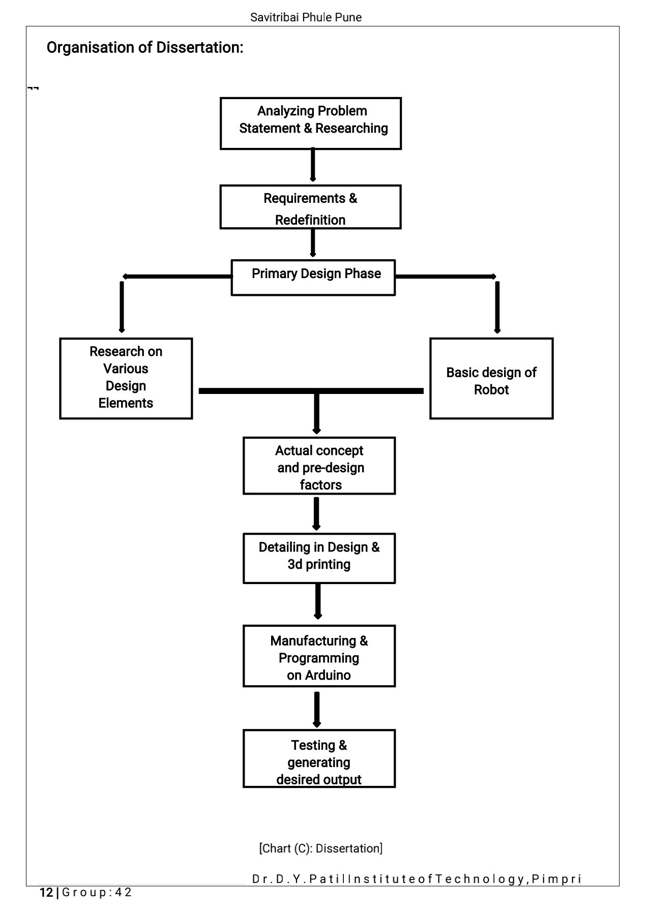

**[Figure B: Organization of Dissertation]**

**Chapter1:**

chapter one is the introduction to the project topic that is XY axis sketching robot. This part gives brief explanation about the objectives, problem statement, scope of the project proposed methodology of the project. XY Axis drawing robot has artistic abilities of drawing. The robot has the capability to draw sketches in a predefined workspace area. Problem statement is to make a robot which is able to draw on vertical surface. One of the important objectives is to execute and analysis the result and make a record and develop a robot which can draw any robot which is easy to operate & install.

**Chapter 2:**

This part contains the literature survey for the detail understanding of the project topic and study of the different research paper like XY plotter, X Y drawing robot using Arduino, Microcontroller based X-Y, Bluetooth Based Android Controlled Robot on the sketching robot. This paper are the main pillars of design and develop the XY axis robot. Each paper gives valuable and addition information about components used; software used in the project. Papers gives inputs regarding different software used that are processing software, Matlab, Inkscape. These papers also give information about hardware used in the project and its working.

**Chapter 3:**

This part examines the full robot overall task along programming advancement. It includes the CATIA diagram, construction of the system, working of the system and description of the components used along with specifications and the set-up of the entire system of the XY axis sketching robot. It also has set-up used for dry run of testing the software and source code and for checking the components working condition. This part includes the hardware components information like stepper motor, servo motor, L296D motor drive shield as well as the stepwise procedure of assembly.

**Chapter 4:**

This element clarifies outcomes got with admire to the execution of the XY axis sketching robot. These outcomes are totally depended on the design of robot, components used in the robot, method used for running the program.

**Chapter 5:**

This chapter includes the discussion on remarks, conclusion and future scope of the XY axis robot. In future how development can be done for cope-up with coming modern technologies is mention like Bluetooth operated. It also discusses the benefits of the system in different areas**.**

**Chapter – 2**

**Literature Review**

|  |  |  |  |  |
| --- | --- | --- | --- | --- |
| **Sr. No.** | **Name of Author/s** | **Title of the**  **Paper** | **Name of the Journal**  **(Vol. No. Year)** | **Relevant Findings** |
| 01 | 1)Sidharth Tripathi  2)Dev Joshi  3)Beauty Sharma | XY Plotter | Volume-6, issue-4, Oct-2018 | For efficient work of robot, they used polarograph server Arduino based program and polar graph processing software. |
| 02 | 1)Mrs. R. Dayna  2) Gunaseelan P | Microcontroller based X-Y plotter | Volume.3, issue 3, Apr 2014 | 1)low power consumable microctroller (MSP430) is used. Which consume 3.5v input  2)For better accuracy draper motor is uesd. |
| 03 | 1) Saurabh Sharma  2) Harish  3) S. B Nikam | X Y drawing robot using Arduino | Volume6 issue 2, | To raise and lower the pen spring is used. And stepper motor is used for moving pen. |
| 04 | 1.Kaustubh Gawli  2.Parinay Karande  3.Pravin Belos  4.Tushar Bhadirke  5.Akansha Bhargava | Bluetooth Based Android Controlled Robot | Volume-5, Issue-3, pp-195-199 | To designing a robot that can be operated using Android Apps using Bluetooth sensor |
| 05 | 1.Rowjatul Zannat Eshita  2.Tanwy Barua  3.Arzon Barua  4.Anik Mahamood Dip | Internet of Things Based robotic arm . | Volume: 04 Issue: 03 | Mar -2017 | They controlled robotic arm with of using IOT sensor which integrate mobile and pc |

[Table A: Literature Review]

1. **XY Plotter, Volume-6, issue-4, Oct-2018**

This paper includes how XY plotter works by using source code. The board is fed with polargraph server Arduino based program which is required for the accurate diagram, and thus with the aid of processing software (version 1.0.5) in which polargraph libraries are uploaded, the robot starts sketching. This paper gives brief idea that sketching robots or 2D plotters are vector graphic devices, (i.e. these devices are contained of tracks, that are well-defined by a starting and finishing points, alongside with further points, curves, and angles traced in the way.) rather than video display, or pixels formation graphics (i.e. it does not uses raster graphics, which is a dot matrix figure arrangement, demonstrating usually a rectangular lattice of pixels, or points of colour accessible by monitor or paper).

In this Arduino based plotter X-Y plane movement is performed. The Arduino microcontroller is easy to use, as it is equivalent to powerful single board computer and the design stages for 2D Plotter Sketching is based on the choice of program used. The software that is to be programmed for the effective functioning of the X-Y plotter, includes polargraph server arduino based program, and polargraph processing software. Hence by this the 2D plotter robot would work efficiently. XY plotter project uses Processing Software version 1.5.1, Arduino IDE version 1.0.5, Polargraph Libraries , Polargraph server code. Paper gives idea about how we can build XY plotter and successfully run by using the processing Software. In this paper image processing term is explained. It guides about path of uploading libraires and stepwise procedure to upload the code.

This work is useful in several micro-positioning and precision uses mainly in 3D Printers. It also delivers the cost-effective way for system understanding and electronics. Generally, the XY plotter stages are used in precision locating industries. They can also find the uses in micromachining, micro fabrications, and stereolithographic tables.

1. **Microcontroller based X-Y plotter, Volume.3, issue 3, Apr 2014**

In this paper, ultra-low power microcontroller of MSP430 is used which consumes only 3.5v as input. Moreover, in several plotter design manufacturers use Pulse Width Modulation based driver circuit which has in-built timer circuit in it which makes the user easy. But, when the user tries to modify the timer, they feel difficult to modify as they wish. So, it is better to use separate timer circuit which is available in microcontroller. MATLAB, IAR Embedded workbench, multisim, proteus, solidworks are the several software used for this project. Most of the plotter is designed in bi-directional movement and square type model.

Whereas X-Y plotter design is concerned, axis movements are mounted on each other and belt driven mechanism for plotting. Main applications are engraving machine, cnc machine, graph plotting machine. Stepper motor, timing belt, timing pulley are used for positioning and to provide better accuracy is the main objective the project. Using MATLAB, researcher can analyse data, develop algorithms, and create models and applications. The language, tools, and built-in math functions enable you to explore multiple approaches and reach a solution faster than with spreadsheets or traditional programming languages, such as C/C++ or Java. Input signals are generated in MATLAB and given to microcontroller through UART. Input signals can be periodic signals, aperiodic or random signals based on the x and y co-ordinates given by the user.

For the movement of solid block structure to move along its path without any shake, guide rod

is used. Based on load, material of the guide rod is chosen. There are several materials such as mild steel, EN8, EN19, EN24, aluminium. Mild steel cannot withstand heavy load whereas EN8 and EN24 can withstand heavy load.EN8 material is used here. This project also uses limit switches which are operated by the motion of a machine part or presence of an object. They are used for control of a machine, as safety interlocks, or to count objects passing a point

This paper gives crystal clear idea about the hardware used in this project and the specification of it and talks about the application of project in the various fields.

1. **X Y drawing robot using Arduino, Volume6 issue 2,**

XY plotter works on the basic principle of Computer Numerical Control (CNC) which is in the control of machining tools (drills, boring tools) and 3D printer by using a computer. A CNC machine holds a bit of material (metal, plastic, wood, fired, or composite) to meet determinations by following a customized code and without a manual. We used acrylic and metal parts used as frame of plotter. It uses two stepper motors which are responsible for X axis & Y axis to move the pen on cartesian plane and a servo motor for up and down mechanism. Arduino Uno is used to take the instructions from computer in form of G code. CNC shield V3 is the microcontroller to drive the motors. Stepper motor driver Pololu A4988 is used to power X and Y axis of the plotter which takes instructions from the Arduino and to increase the accuracy and efficiency we use G codeconverter.

The Arduino based XY drawing Robot using CNC Shield is used in the Arduino board which is used to draw fast and efficient drawings or pictures which can be taken from source converted to scalar vector graphics (SVG) format given as an input. The input is fed in to the input port of the micro controller. Stepper motors are used to set the position of the pen to the origin and a servo mechanism used to lift and lower the which displays the output on the paper. This paper also gives introduction to the Inkscape software and its role in the project. paper includes specification of motors used.

**4. Bluetooth Based Android Controlled Robot, Volume-5, Issue-3, pp-195-199**

The paper provides information of aim of the project aims in designing a robot that can be operated using Android Apps. The controlling of the Robot is done wirelessly through Android smart phone using the Bluetooth module feature present in it. This project is a Bluetooth controlled robot. For this the android mobile user has to install an application on her/his mobile. Then user needs to turn on the Bluetooth in the mobile. The wireless communication techniques used to control the robot is Bluetooth technology. User can use various commands like move forward, reverse, stop move left, and move right. These commands are sent from the Android mobile to the Bluetooth receiver. Android based robothas a Bluetooth receiver unit which receives the commands and give it to the microcontroller circuit to control the motors. The microcontroller then transmits the signal to the motor driver ICs to operate the motors.

The main objective of the project mentioned in this project are as follows:

1. Operating the Robot wirelessly through mobile phone.

2. Usage of Android touchscreen smart phone in performing the task.

3. Bluetooth wireless transmission.

4. Indicating Robot directions using LED indicators

This project consists of a microcontroller, 16 x 2 alphanumeric LCD, two 5V relays, a lamp, DC motor and Bluetooth module. Here at89c51 microcontroller is used. It is an 8-bit microcontroller and it requires supply voltage of 5V DC [5] [6]. Use 7805 power supply circuit to provide 5V DC to the microcontroller. For the above circuit additionally, you need to connect reset circuit and crystal circuit to the controller to work properly.

According to the paper project has its application as surveillance device, home automation, wheelchairs, military applications, hostages rescue. It is feasible to implement Bluetooth communication between smartphone and microcontroller. It can be used in various industries for picking various objects where human intervention is not desired. On a large scale, it can be used to develop robots with military applications. It can be used to target enemy without any human being crossing the territory. It provides for more development of applications based on android operating system.

**5. Things Based robotic arm, Things Based robotic arm.**

This research paper deals with robotic arm, which can pick and place things from one place to another. To control this action, we can move the robotic arm by giving specific commands. The robotic arm is equipped with servo motors. These motors help to move the arm in desired direction. The motors are controlled with the help of a micro controller (FRDM KL25Z). The user interface which is used to control the robotic arm is made on a web page or an app. The control is given via the internet to the WIFI module (ESP8266). This acts as the receiver and gives the received signal to the microcontroller. The signal which misgiven to the robotic arm is actually sent through the internet.

In order to communicate with the Robotic arm over the internet, they are using Wi-Fi module ESP 8266. It is a self-contained SOC and can be used with any microcontroller to access Wi-Fi network. It consists of 32-bit low powered CPU, and follows 802.11 b/g/n Wi-Fi standard. It has a powerful on-board processing and storage capabilities, and is extremely cost effective. The ESP module can be directly connected to our KL25Z board. Here we are using serial communication between ESP 8266 and KL25Z. A Wi-Fi based web server is made with a graphical user interface, and controls are given through this GUI. The signals when sent to the module can be given serially to the controller board and then to the servo motors of the robotic arm.

According to this paper project were able to control the Robotic arm not only using the wired controls but with the help of Internet of Things which is the growing technology in recent times we successfully controlled the robotic arm using the IoT interface. This can be useful to various industrial applications where machines need to be controlled from distant places.

It has many advantages like lifting and moving heavy objects, increasing productivity, safety, efficiency, and quality of products. achieving more accuracy than human beings easy to monitor and control things.

**Chapter – 3**

**Design work**

The most important aspect of this thesis is the mechanical design of The XY Axis sketching robot. There are different types of designs comes in mind at the initial stages of the design. As earlier stated in the introductory chapter of this report XY Axis sketching robot has two degrees of freedom. All the components of XY Axis sketching robot designed by using CATIYA software. The CATIYA model is shown in Figure below.

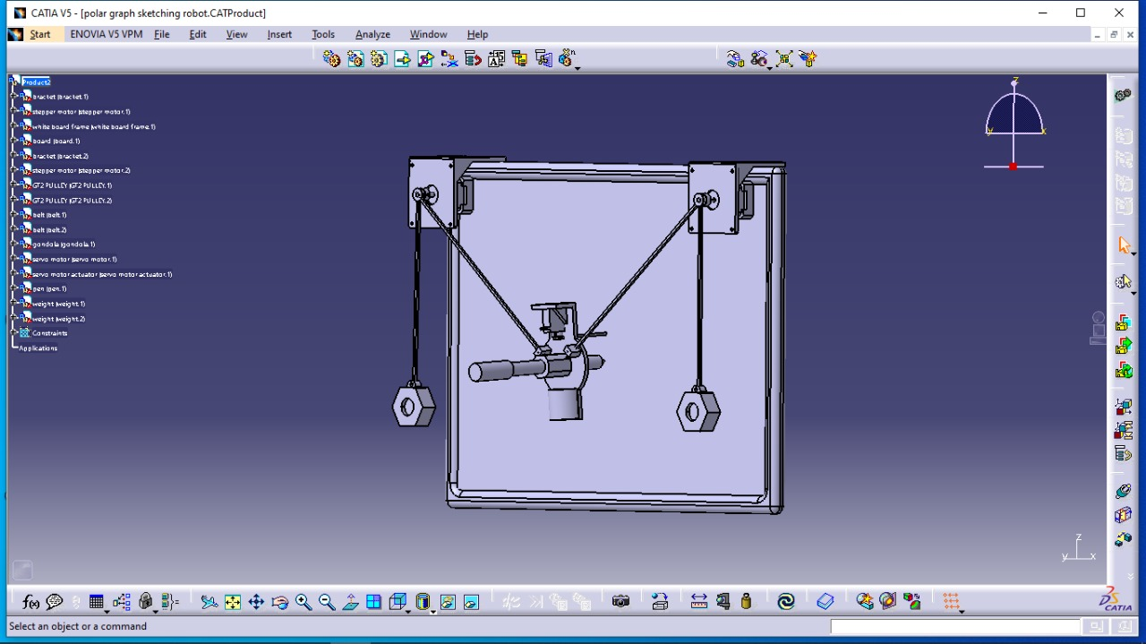 [Figure C: Assebly of robot]

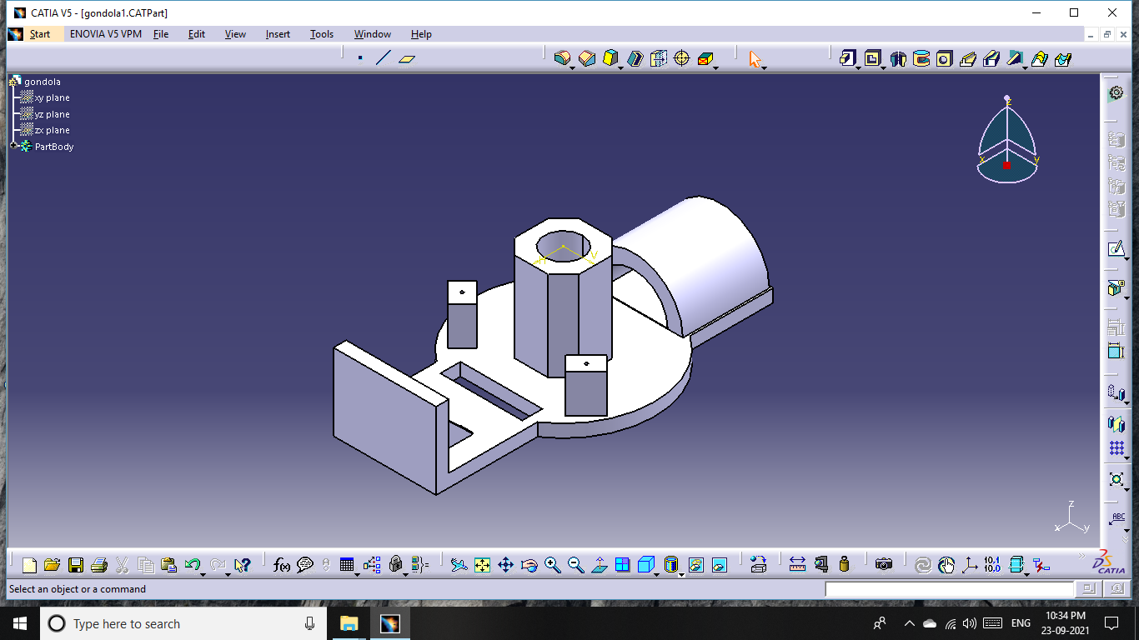

[Figure D: Pen Holder**]** 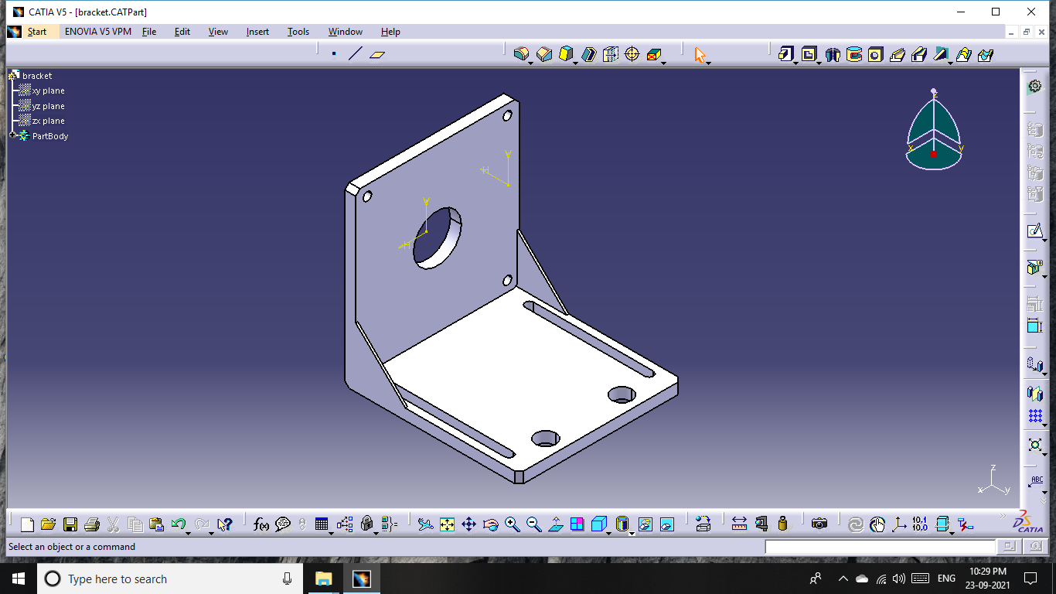

[Figure E: Mounting Brackets ]

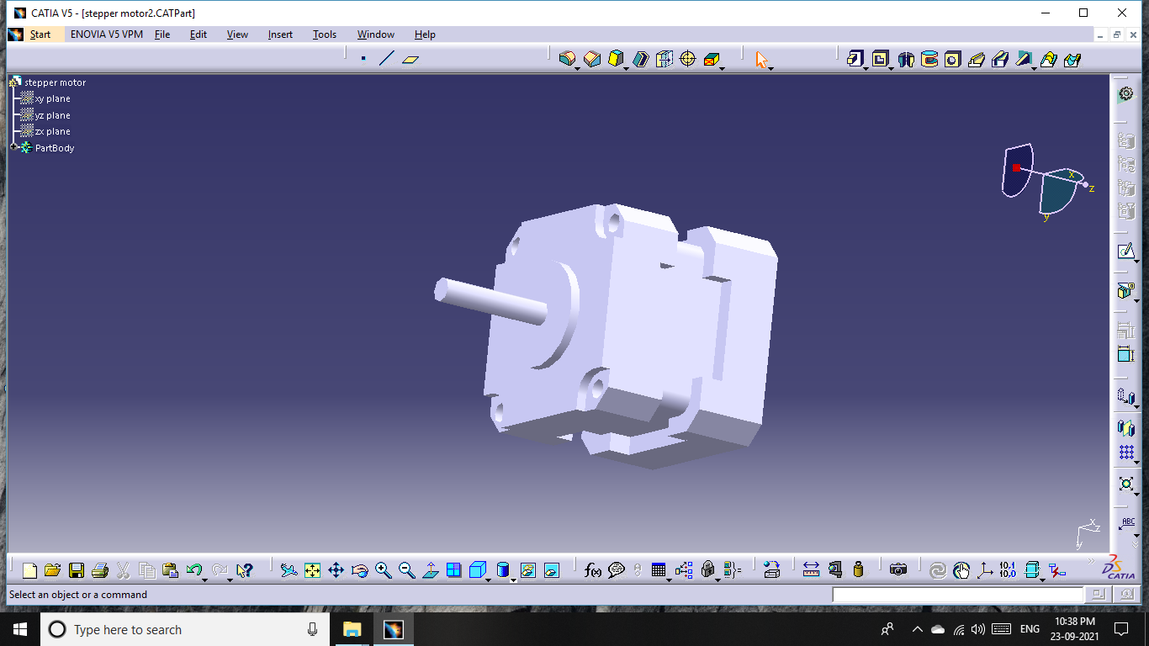

[Figure F**:** Stepper Motor]

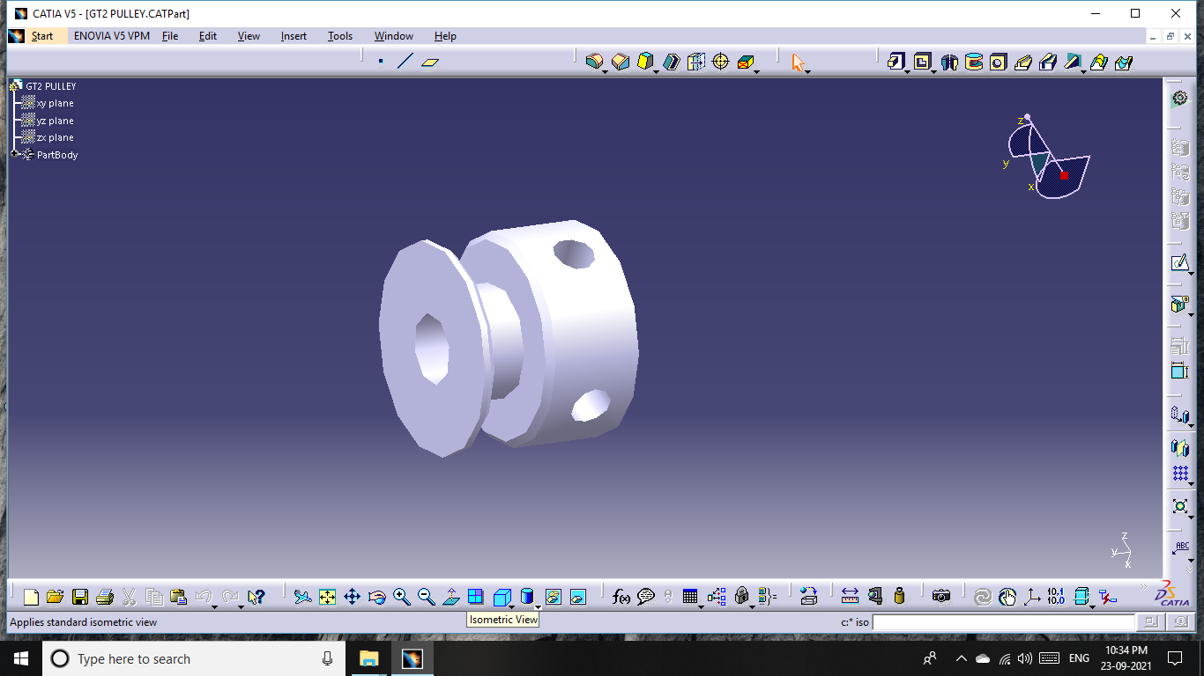

[Figure G: GT 2 Pully]

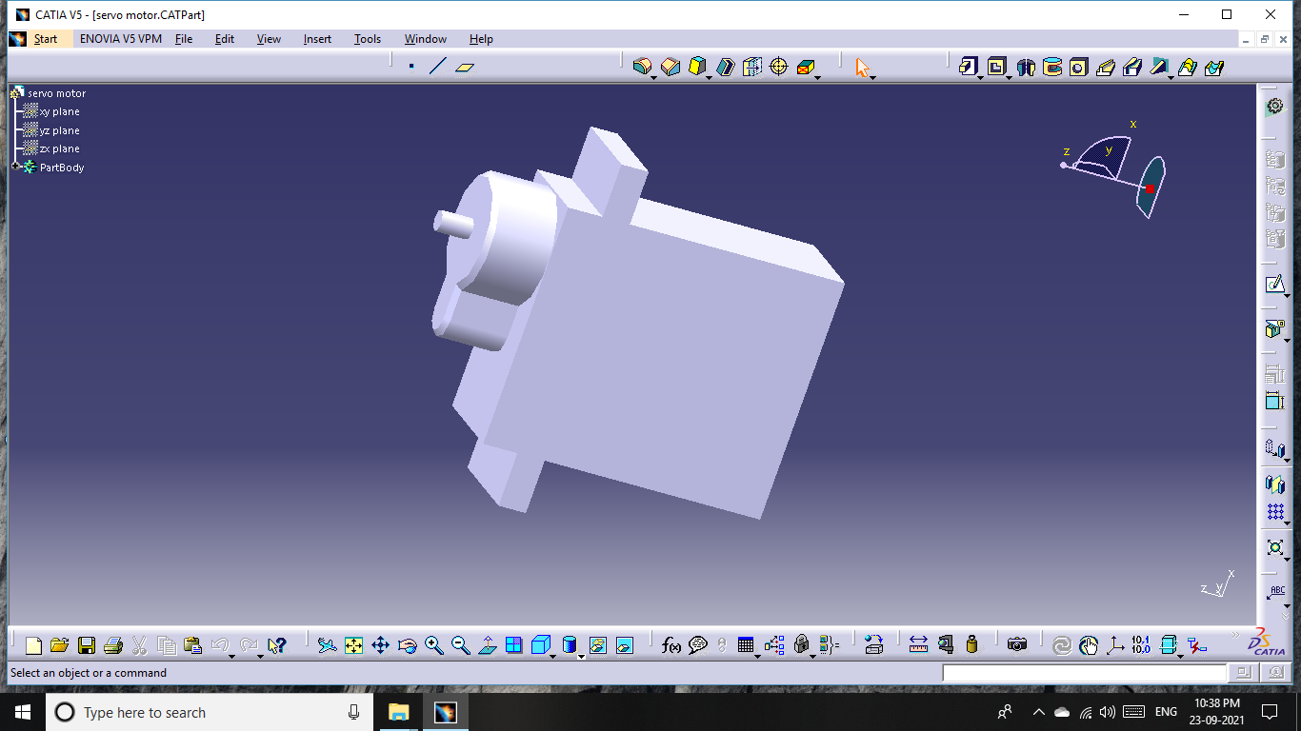

[Figure H: Servo motor]

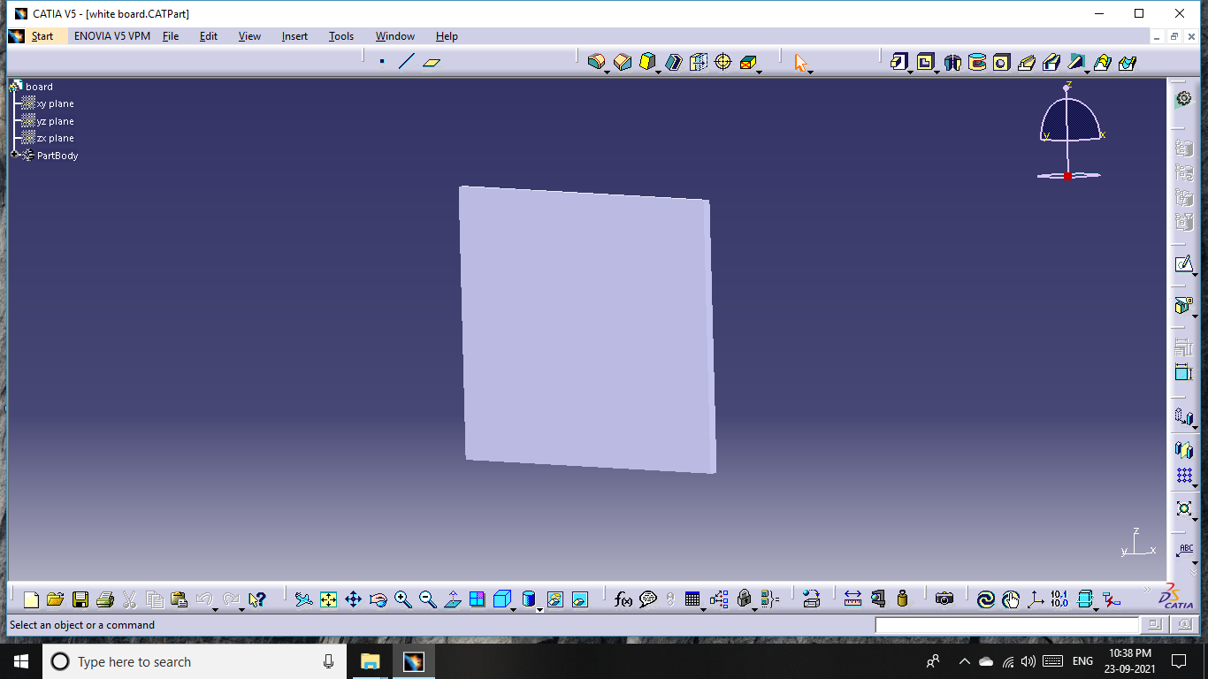

[Figure I: Board]

**Machine Dimension:**

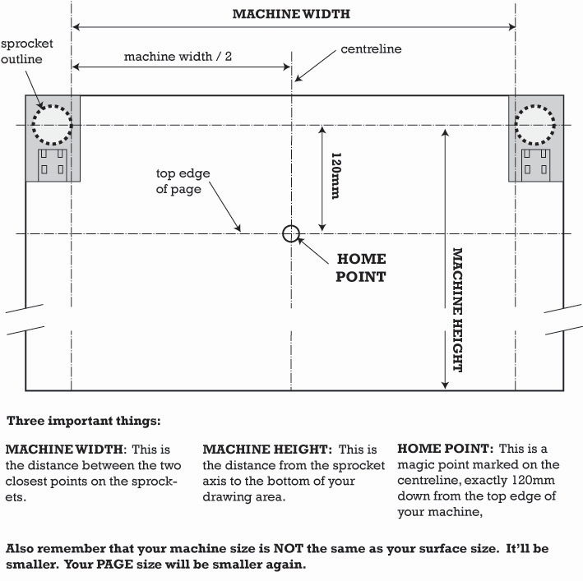

[Figure J: Machine Dimension]

The important parameters of machine design regarding board which is mounted on the wall are as follows:

1. **Machine Width**: This is the distance between two closest points on the sprockets (between two pulleys).
2. **Machine Height**: This is the distance from the sprocket axis to bottom of your drawing (board) area.
3. **Home Point:** This is a magic point marked on the centreline, exactly 120mm (12cm) down from the top edge of your machine. OR It is the point which we can set on the board according to the sketch which we want to draw on the board.

|  |  |
| --- | --- |
| SKETCHING ROBOT TECHNICAL SPECIFICATION (mm) | |
| Machine width | 780 |
| Machine height | 450 |
| Home point | 280 |
| working dimensions | 430L*320W |

[Table B: Technical specification]

**Hardware Design:**

Main components of hardware design are Arduino UNO R3, stepper motor, L293D Motor Drive Shield, 17 Stepper Motor, MG90S Servo Motor, GT2 Pulley 16 Teeth Set, GT2 Rubber Belt, pen holder and mounting brackets.

**Arduino:**

Arduino Uno is a microcontroller board based on the ATmega328P. It has 14 digital input/output pins (of which 6 can be used as PWM outputs), 6 analogue inputs, a 16 MHz quartz crystal, a USB connection, a power jack and a reset button. It contains everything needed to support the microcontroller; simply connect it to a computer with a USB cable or power it with an AC-to-DC adapter or battery to get started. Arduino Uno is used for sending electrical signal to the motors.

**Specifications:**

|  |  |
| --- | --- |
| Microcontroller | ATmega328P |
| Operating Voltage | 5V |
| Input Voltage (limit) | 6-20V |
| Digital I/O Pins | 14 |
| PWM Digital I/O Pins | 6 |
| Analogue Input Pins | 6 |
| DC Current per I/O Pin | 20 mA |
| DC Current for 3.3V Pin | 50 mA |
| Flash Memory | 32 KB (ATmega328P) |

[Table C: Arduino Specifications**]**

**L293D motor drive shield:**

L293D shield is a driver board based on L293 IC, which can drive 4 DC motors and 2 stepper or Servo motors at the same time. L293D use 16 pin DIP package, its internal integration is bipolar H - bridge circuit. This kind of bipolar pulse width method has many advantages, such as the current continuous, or microcurrent vibration when the motor stops, which as a lubrication effect. It can eliminate the dead zone of static friction when positive and negative.

**Specifications:**

|  |  |
| --- | --- |
| Motor controller | L293D, Drives 2 DC motors or 1 stepper motor |
| Operating Voltage | 5V to 12V |
| Max current | 6-20V |
| Peak Output Current | 1.2 Amp |
| Dimensions | 70 x 54 mm |

[Table D: L293D motor drive shield Specifications]

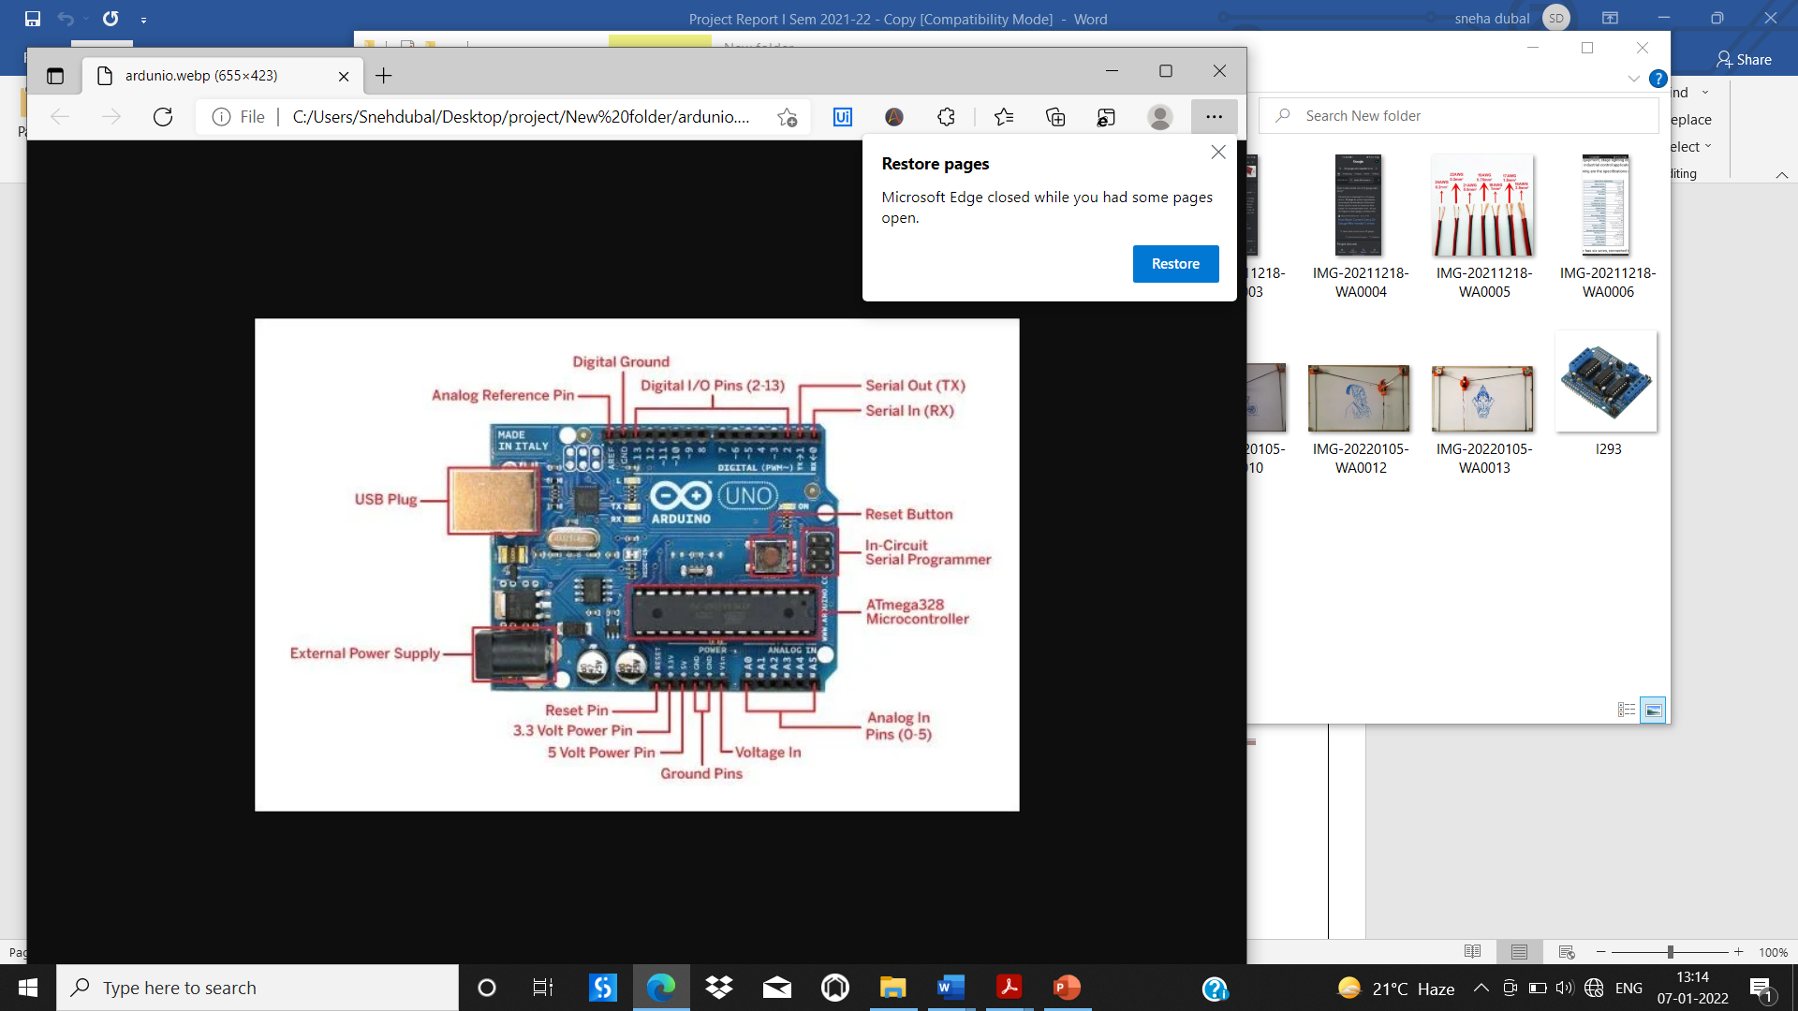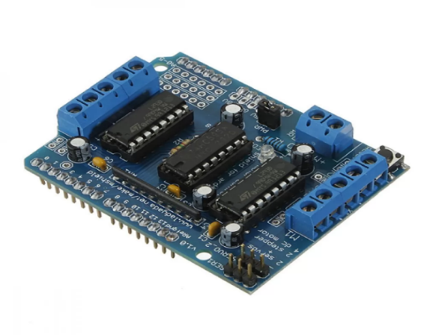[Figure K: Arduino and L293 motor drive shield]

**Stepper motor:**

 Stepper motor is an electric motor that divides a full rotation into a number of equal steps. The amount of rotation per step is determined by the motor structure. These motors have a very high accuracy. Functioning of motor is based on stepping action. There are several stepping modes. They are full step, half step, micro step. Normally the sequence for motor is A+ A- B+ B-. Main consideration of stepper motor is torque and power rating. Based on the torque, load can be used for driving. Two stepper motor is used for x-axis and y-axis movement.  **Specifications:**

|  |  |
| --- | --- |
| Size | NEMA 17 |
| Angle Step | 1.8 degree Full step , 0.9 degree half step |
| Voltage & Current | 12 V at 400 mA |
| Operating Speed @6.6V | 2.2kg-cm |
| Holding Torque | 2000 g-cm |
| Detent Torque | 220 g-cm max |
| Operating Temperature (°C) | -10 º to 55 ºC |
| Weight | 0.24kg |
| Shaft diameter | 0.197 in (5 mm) |
| L * w * H | 1.7 in x 1.7 in x 1.5 in |

[Table E: Stepper motor Specifications]

**Servo motor:**

By using a servo, we will be able to control the amount of shafts rotation and move it to a specific position. The Tower pro MG90S Mini Digital Servo is 180° rotation servo. It equips sophisticated internal circuitry that provides good torque, holding power, and faster updates in response to external forces high resolution. Servo motor has features like accurate positioning, fast control response, Constant torque throughout the servo travel range, Excellent holding power. We are using servo motor for the up and down movement of pen holder while sketching **Specifications:**

|  |  |
| --- | --- |
| Model | MG90S |
| Operating voltage | 4.8V~ 6.6V |
| Operating Speed @4.8V | 1.8kg-cm |
| Operating Speed @6.6V | 2.2kg-cm |
| Stall Torque @ 4.8V (Kg-Cm) | 1.8 |
| Stall Torque @6.6V (Kg-Cm) | 2.2 |
| Operating Temperature (°C) | 0 to 55 |
| Rotational Degree Servo Plug | 180º |
| Servo Plug | JR |
| L * w * H | 12.5 X 22.8 X 32.5 |

[Table F: Servo Motor Specifications]

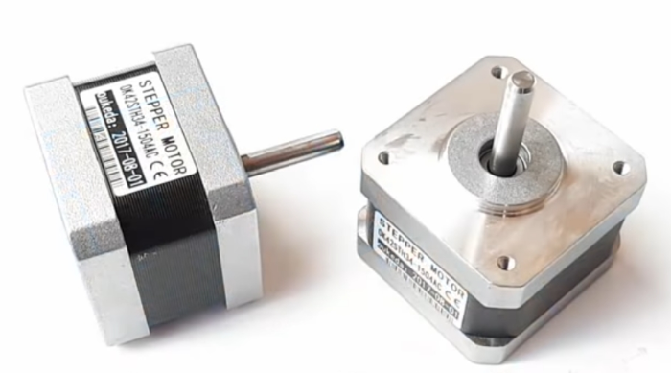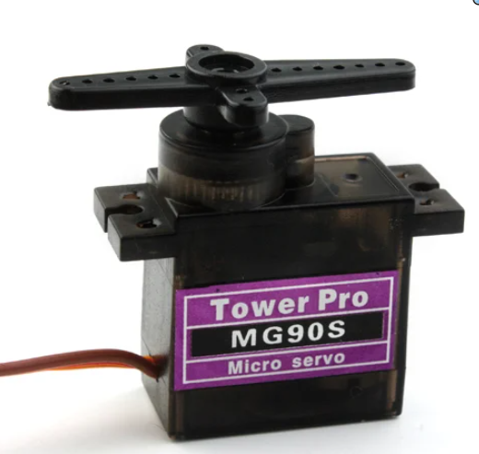

[Figure L: Stepper motor and Servo Motor]

**GT2 Rubber Belt:**

There are several types of belts made of different material. In this paper, timing belt is used because of its accuracy and positioning. Timing belts are available in rubber, fiber-in forced in rubber and Poly Urethane material with different circumference. If application is based on the oil and water, then poly urethane belt is preferred. If the application is based on the open environment, then fibre reinforced belt is preferred. The Belt is also called as the synchronous belt is popularly known for its non-slipping mechanical drive belt. It is composed of the flexible belt which contains a row of teeth embedded on the inner surface of the belt. Timing pully and belt works when the toothed parts become compatible with each other. We used Timing belt for providing movement in the x and y direction to the pen holder. we chose it because power transmission efficiency is not lost with the use a clean operation, no need for lubrication

**Specifications:**

|  |  |
| --- | --- |
| Material | Neoprene Rubber with Fiberglass Core |
| Shape | Open Loop |
| Total Length | 5 M |
| Pitch (mm) | 2 |
| Width (mm) | 6 |
| Tooth Height | 0.76 |
| Belt Height(mm) | 1.52 |

[Table G: GT2 Rubber Belt Specifications]

**Pulley:**

Pulley can be made with different type of material such as plastics, steel, aluminium and nylon block. As compared to other material aluminium gives long life. Pulley parameters are hub, pitch, flange, key lock, inner diameter and outer diameter. This pulley has 16 teeth and a 5mm inner bore. Two set screws can be used to attach it firmly to any 5mm diameter shaft. Full aluminum construction means these are very light and very durable.

**Specifications:**

|  |  |
| --- | --- |
| Material | Aluminum. |
| No. of teeth | 16 |
| Outer Diameter | 13mm |
| Inner Diameter | 5mm |
| Length | 14 mm |
| Weight | 6 gm |

[Table H: Pulley Specifications]

**Pulley:**

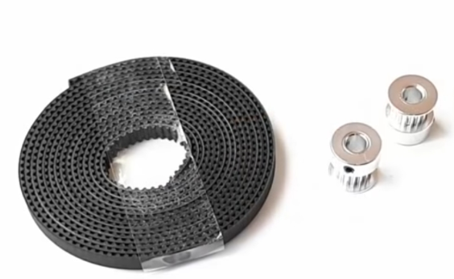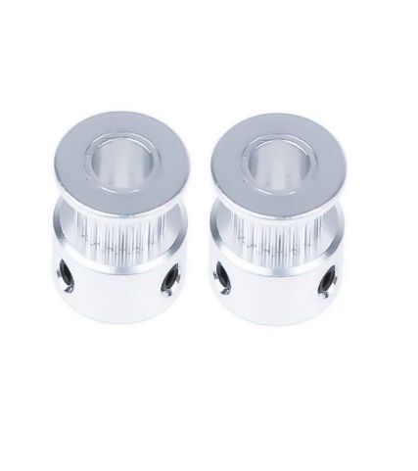

[Figure M: GT2 Rubber Belt and GT2 16 Teeth Pulley**]**

**Mounting bracket and Pen holder:**

Mounting bracket and pen holder are the components that are printed by 3 D printer. Pen holder and Mounting bracket are designed in the CATIA software and then converted into the STL file format. Then used 3D printing software ultimaker cura for the simulation purpose and checking its different parameters. There are different materials used for 3D printing and they are ABS+, SILK PLA+, PETG, NYLON, WOOD FILL, CARBON FIBRE. We used polylactic Acid known as PLA most popular material having tiger orange color and required to operate nozzle temperature between 195-215 ºC .

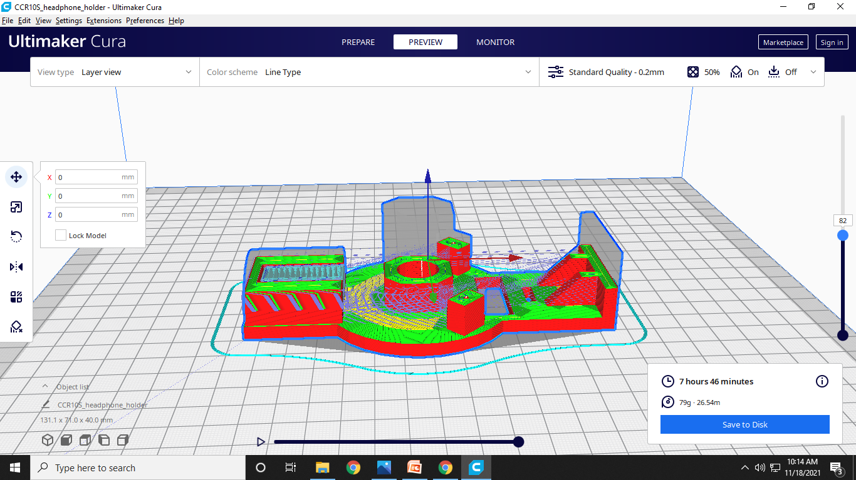 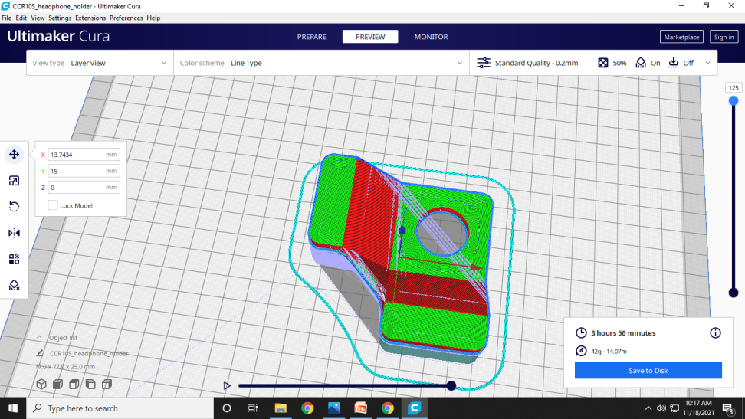

3D Printing parts preparation using software : Ultimaker Cura

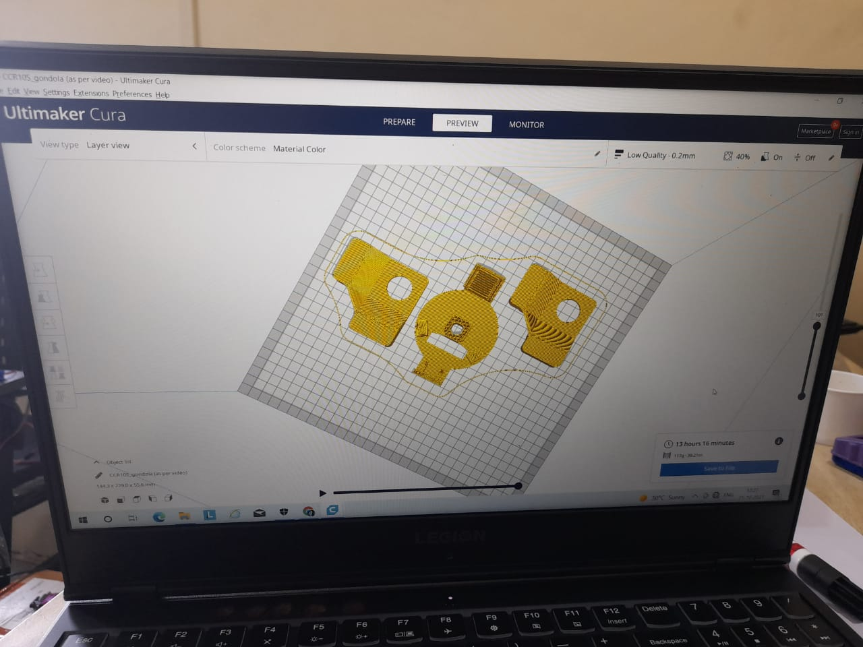

[Figure N: Simulation in Ultimaker Cura software**]**

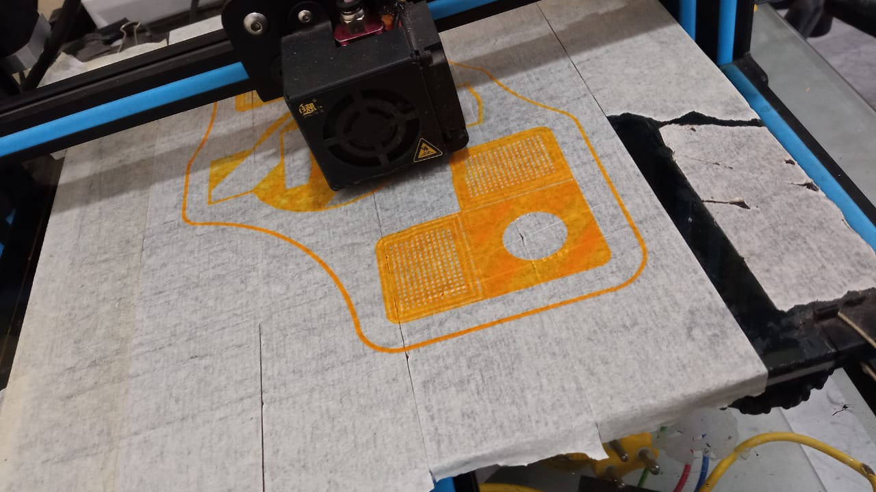

[ Figure O: 3D printing of pen holder and mounting brackets ]

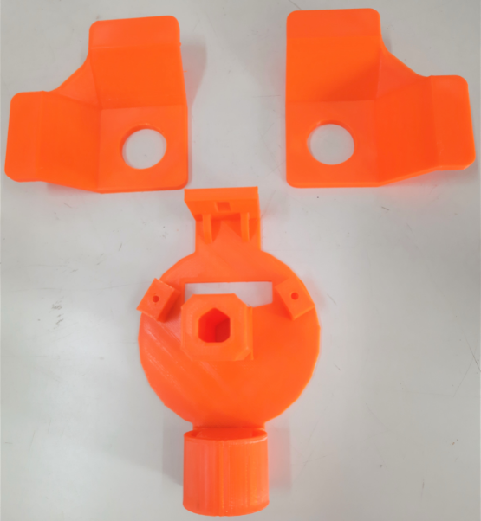

**[Figure P: Pen holder and Mounting Brackets]**

**3.2Construction:** Construction of the robot contains assembly of the pen holder, servo motor and the stepper motor with the belt and pully on the board.

Stepper motor was fixed on the mounting stepper brackets



Servo motor are rubber are belts connected on both sides of the pen holder, so that the movement of pen holder can be adjusted with the rubber belts.

**sdghh **

Then stepper motors are fixed on the upper corners of the board. GT2 pulley teeth are attached to the stepper motors, and pass the rubber belts through each of the motors and attached balancing weight at the end of the rubber belt, so that the belt becomes firm and fit to the motors.



Then a pen fitted on the pen holder which controls the up and down movement of the marker pen and L293D Motor Drive Shield mounted on the Arduino uno and connection connected to the servo motor, stepper motor and to the computer.

****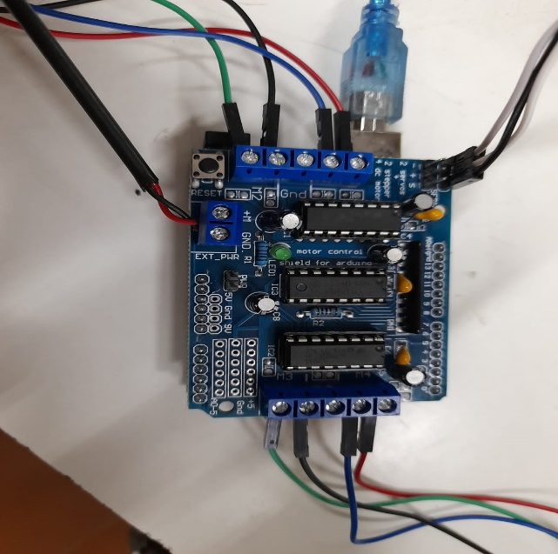

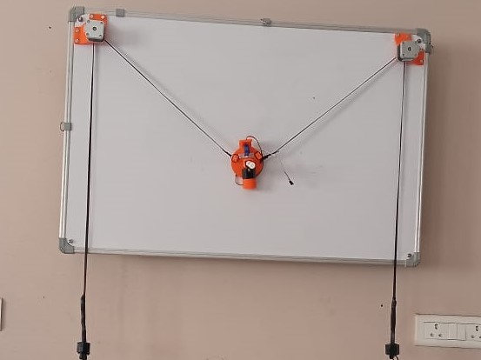

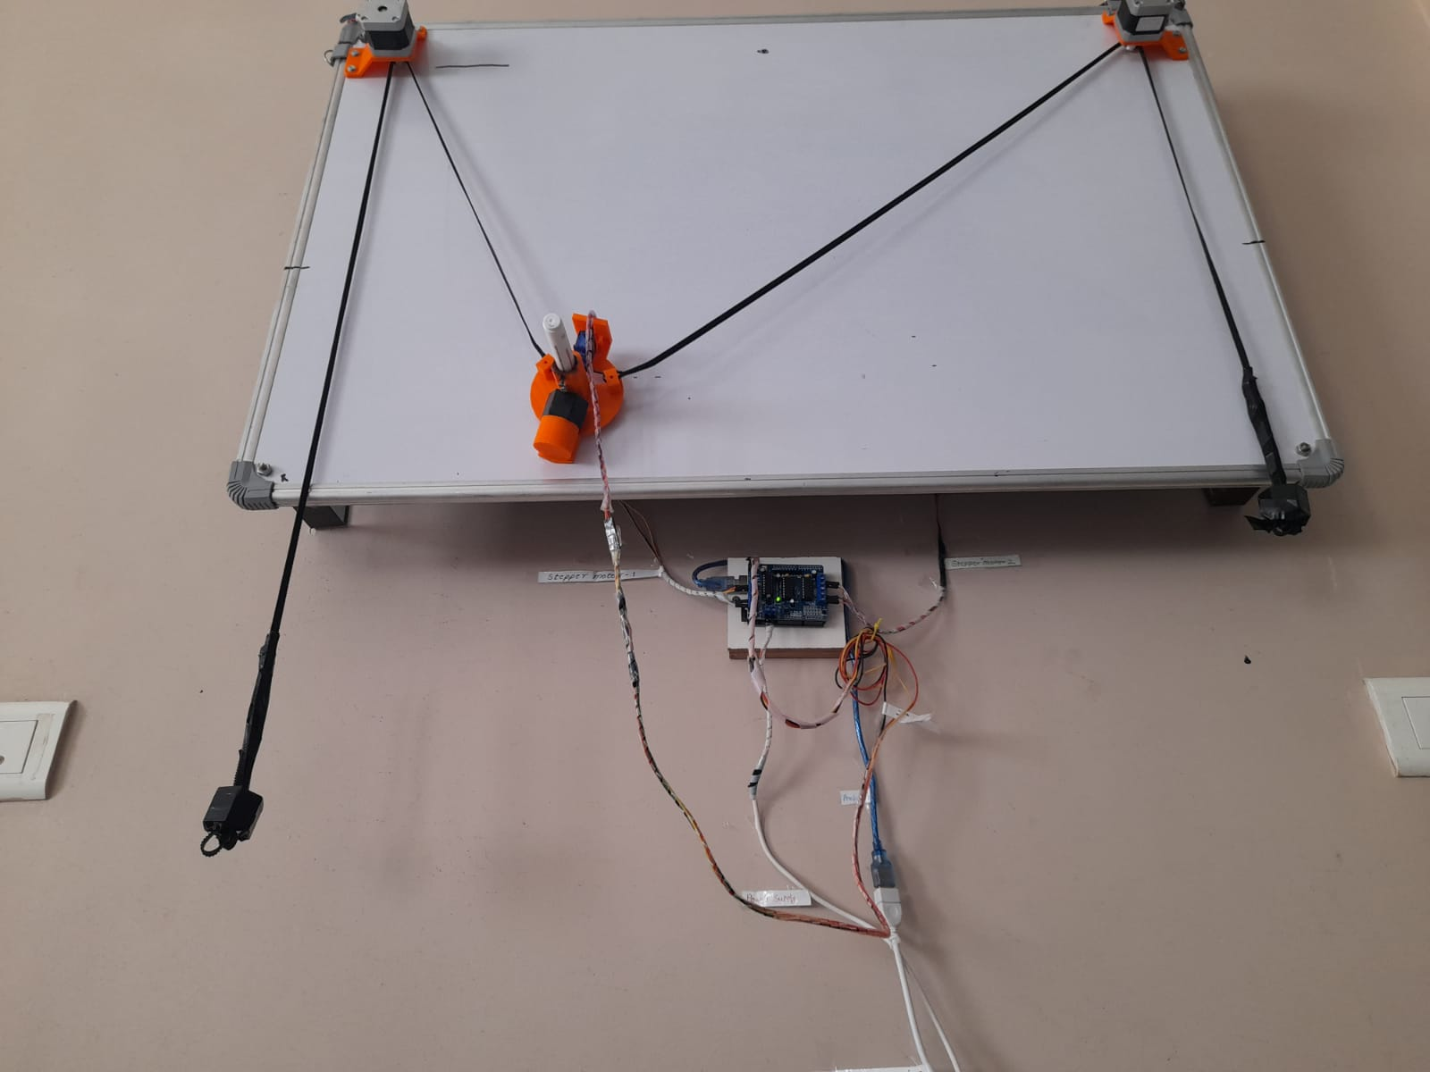

[Figure Q: final assembly picture of robot on the board hanging on the wall.]

**3.3 Working of System**

This low cost XY axis sketching robot works on the basis of G code working. The connection to the Arduino is shown as follows.

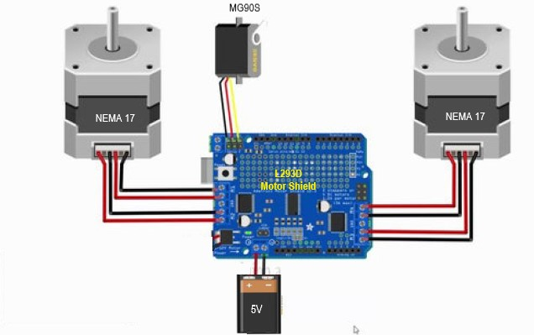

[Figure R: Arduino Circuit for the system]

Power supply is given by PC to the to give it command. Arduino IDE, makelangelo software and SVG format file are used to complete the working of X-Y axis sketching robot .

Robotics is the upgraded technology, it is used for efficiency, welfare, and in saving time and money. sketching robot is used offers the work built on the principle of CNC which concentrates on a variety of works. This XY axis robot which is basically cantered to the scalar vector graphics image type where the robot designs or sketches the input given from the computer on the drawing board or a sheet of paper using Arduino UNO microcontroller and makelangelo software. The drawing robot is designed to work with the help of opensource software Inkscape and Makelangelo. Inkscape provides a platform to input the sketches and then convert them in the form of SVG format. The robot has the capability to draw sketches in a predefined workspace area.

A 2d image is converted to G code so that the computerized machine tools could understand. G code is nothing but a numerical control programming language used to control automated machinetools**.** This G code contains instructions on where to move,how fast to move, and what path to move. The machine tool (pen) moves according to these instructions and draw

the image. The makelangelo software generates G code of our desired image. Then the G code is transferred to Arduino which will analyse the G code and the program of sketch will be uploaded by Arduino to motor shield drive motors using given information. and electrical signal through Arduino send e commands to respective stepper motor drivers and servo motors having connection to the pen holder. Based on commands pen holder moves in the X and Y direction and pen up and down motion will be done by servo motor and we get output as desired sketch on the board. For operating first time the software we have to upload below code in the Arduino. For operating first time the software we have to upload below code in the Arduino.

* 1. **Experimental Setup**

**Dry Run set up**

Before going for direct assembly, we decided to check material working condition, source code available at our end, for practice purpose for getting hands practice on software are installed that we will going to use for further working of project to run XY axis sketching robot. This is prototype model build before assembly for dry Run Purpose. We choose box as our pen holder and Allen key as dead weight we took are first dry run. In this dry run we understand the importance of dead weigh balancing and clearance less fitting of belt on the on pully which is mounted on the shaft of stepper motor.

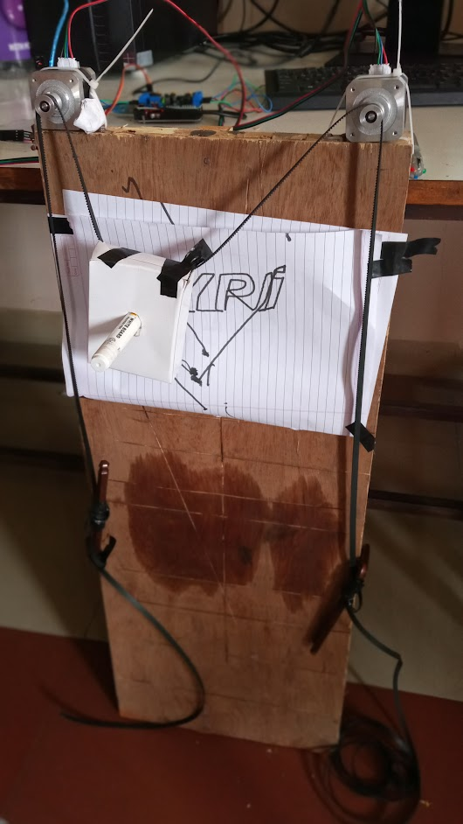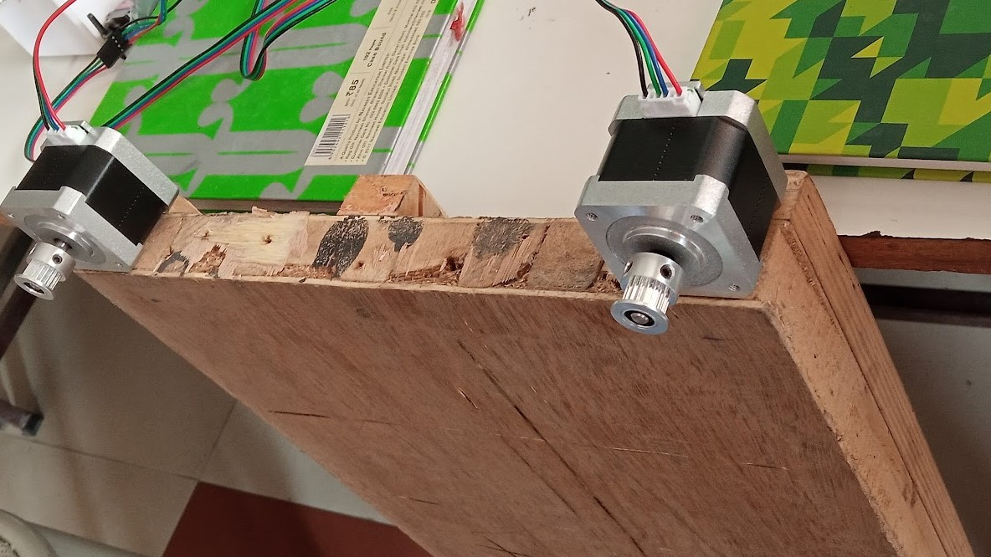

[Figure S: Dry Run Set up]

After dry run final assembly. The procedure for giving input to the software is as follows:

**Stepwise procedure:**

1. First convert the image to be drawn in the SVG file format by using online SVG converter or we can use Inkscape software for creating SVG file. Then follow the following procedure step by step.
2. Open the Makelangelo software. After opening u will find below user interface. Click on the connect. Select the COM port. We will get setting, manual driving, creative control, animation control tabs for providing input.

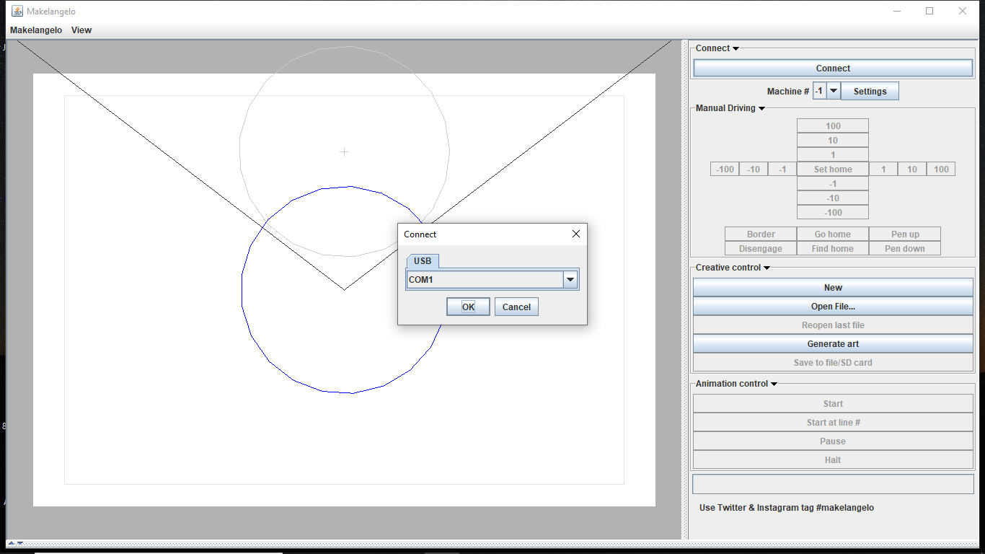.

1. After selecting the COM port. We have to wait for few seconds only after successful connection we get access of manual driving tab like following figure.

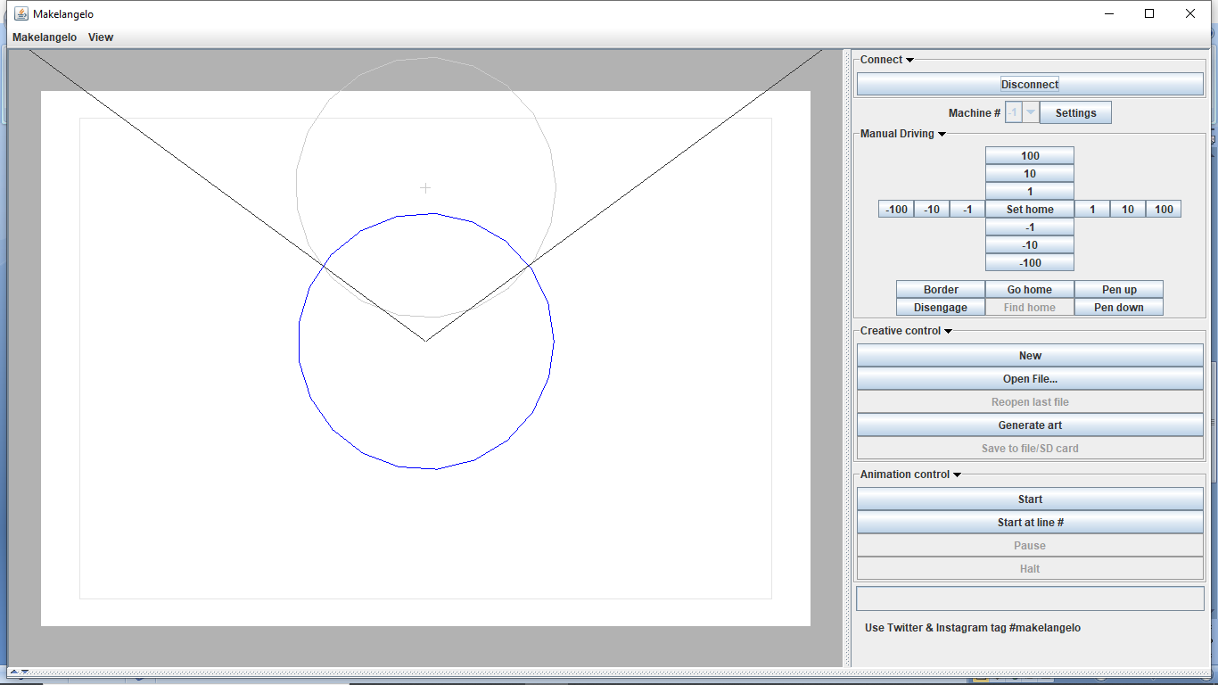

1. By clicking on the open file, we can take the desired image that we want to sketch on the board and never forget to select the SVG file type while selecting image.

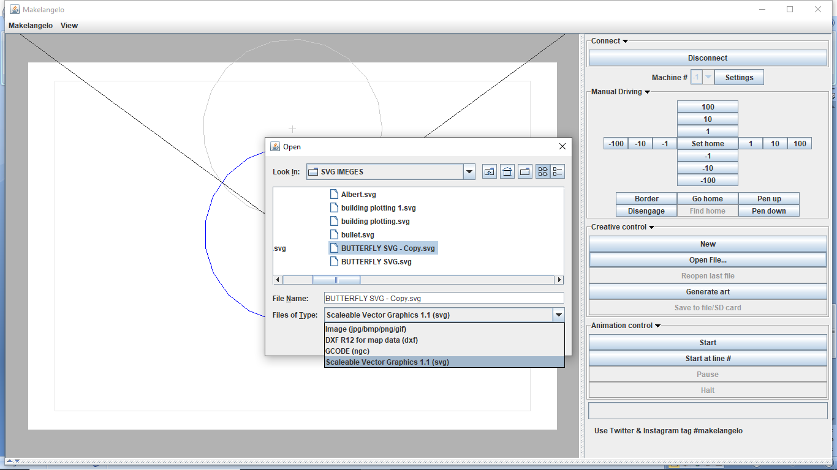

1. After selecting image it apperars on the sketching area. Here we get preview of the image which will XY axis sketching robot draw on the board as shown in the following snapshot.

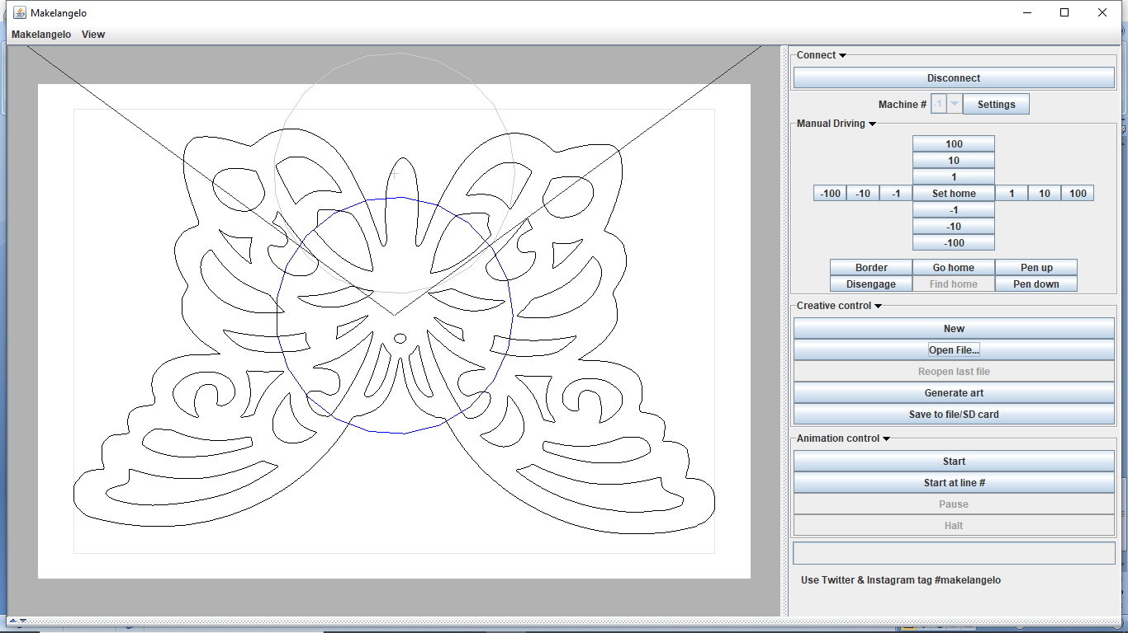

1. By clicking on seeting , we can change the settings of pen holder , sketching area that is of paper and machine as well for better , accurate and beautifull sketch .

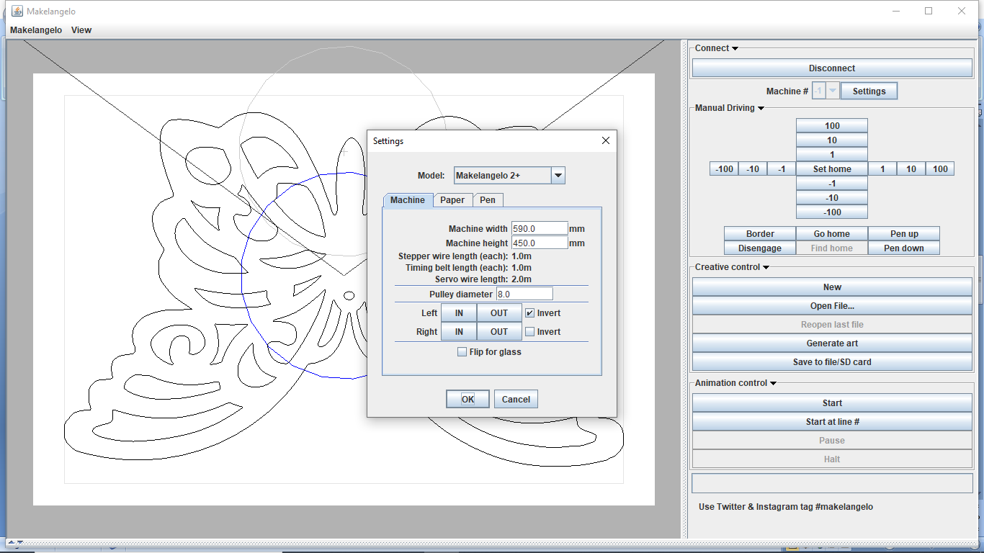

1. Once finish the setting. Click on set home and set the pen at the point from where we want start sketch with help of manual driving. Then click on start button. XY axis sketching robot will start sketching. 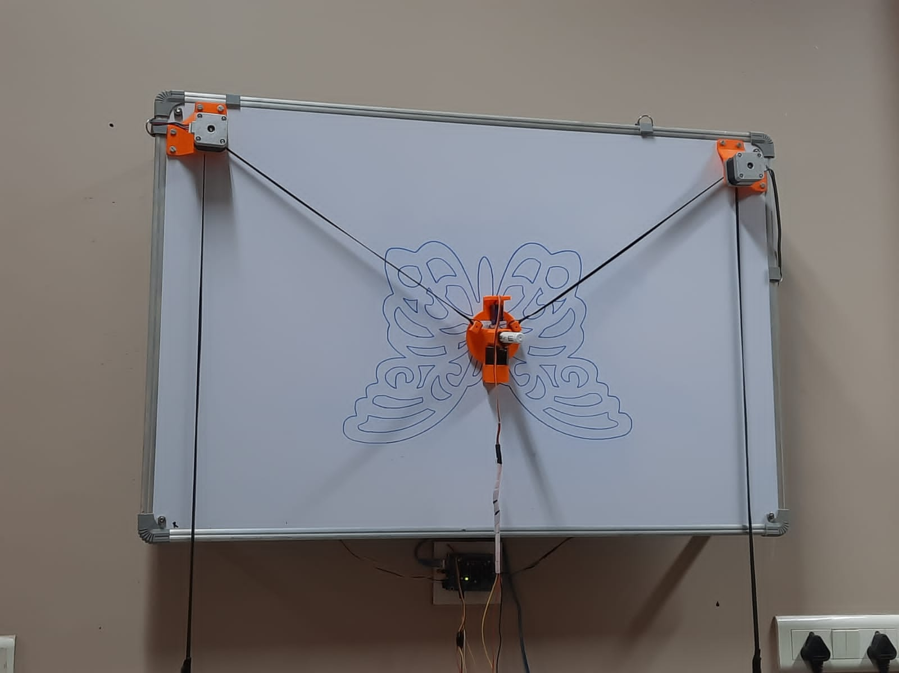Following are the sketches drawn by the XY axis sketching robot while taking trials.

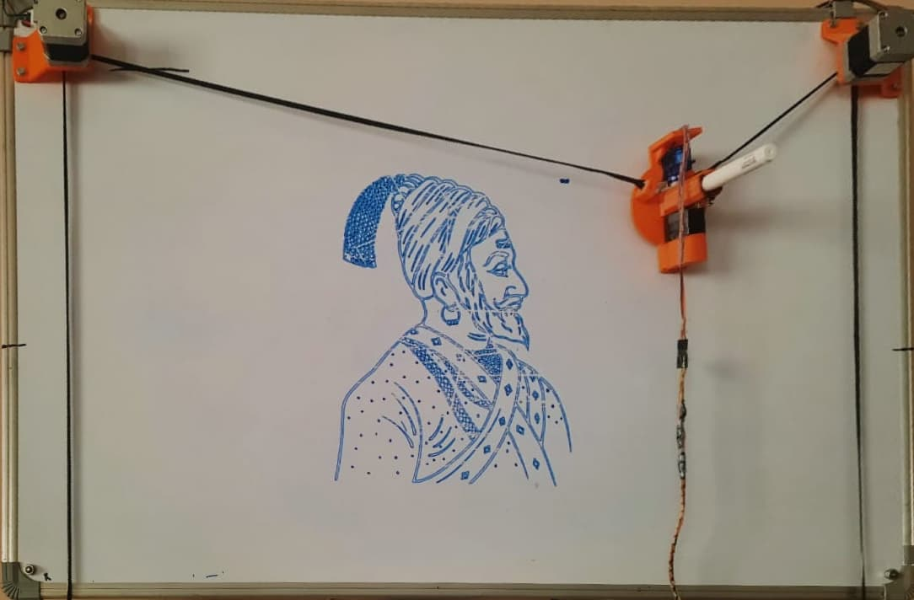

[Sketch A: Shivaji Maharaj]

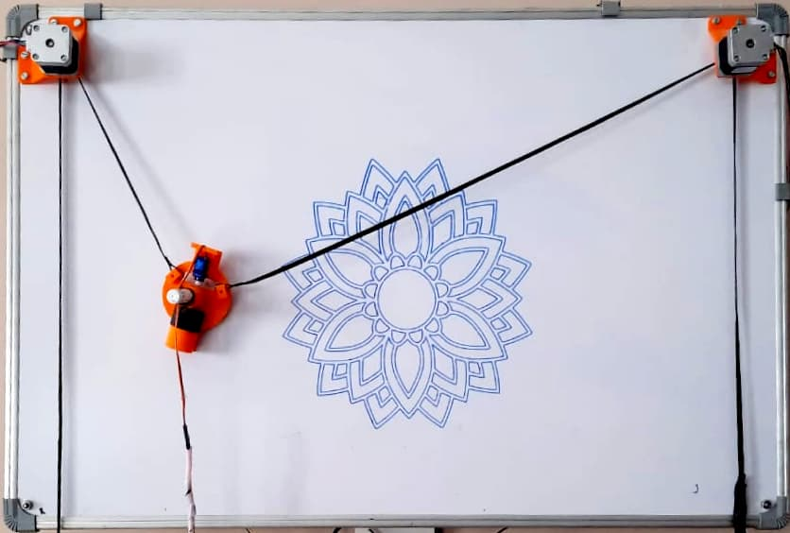

[Sketch B: Rangoli]

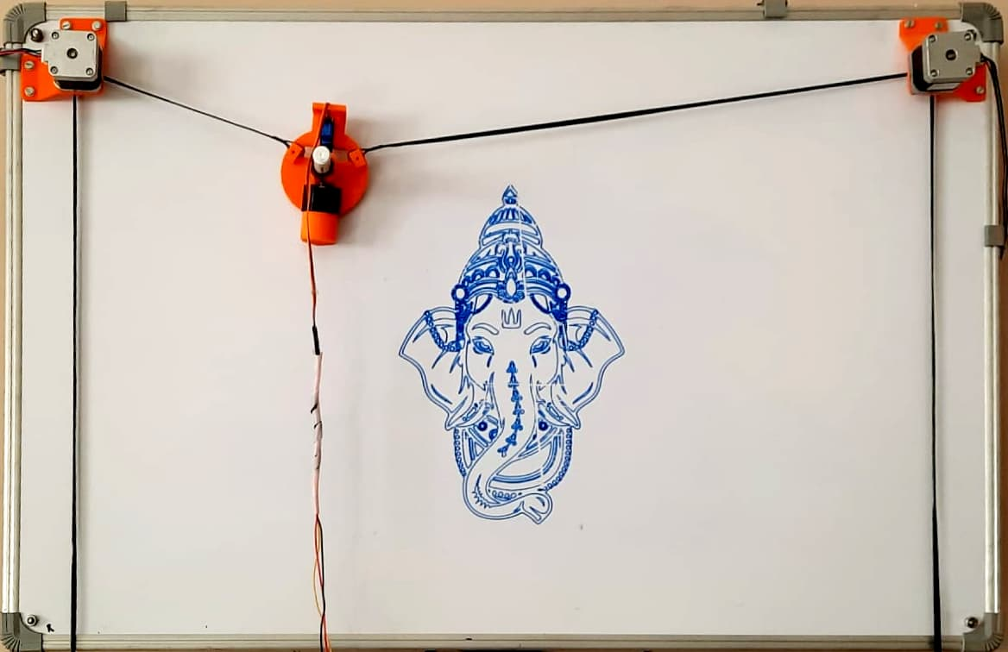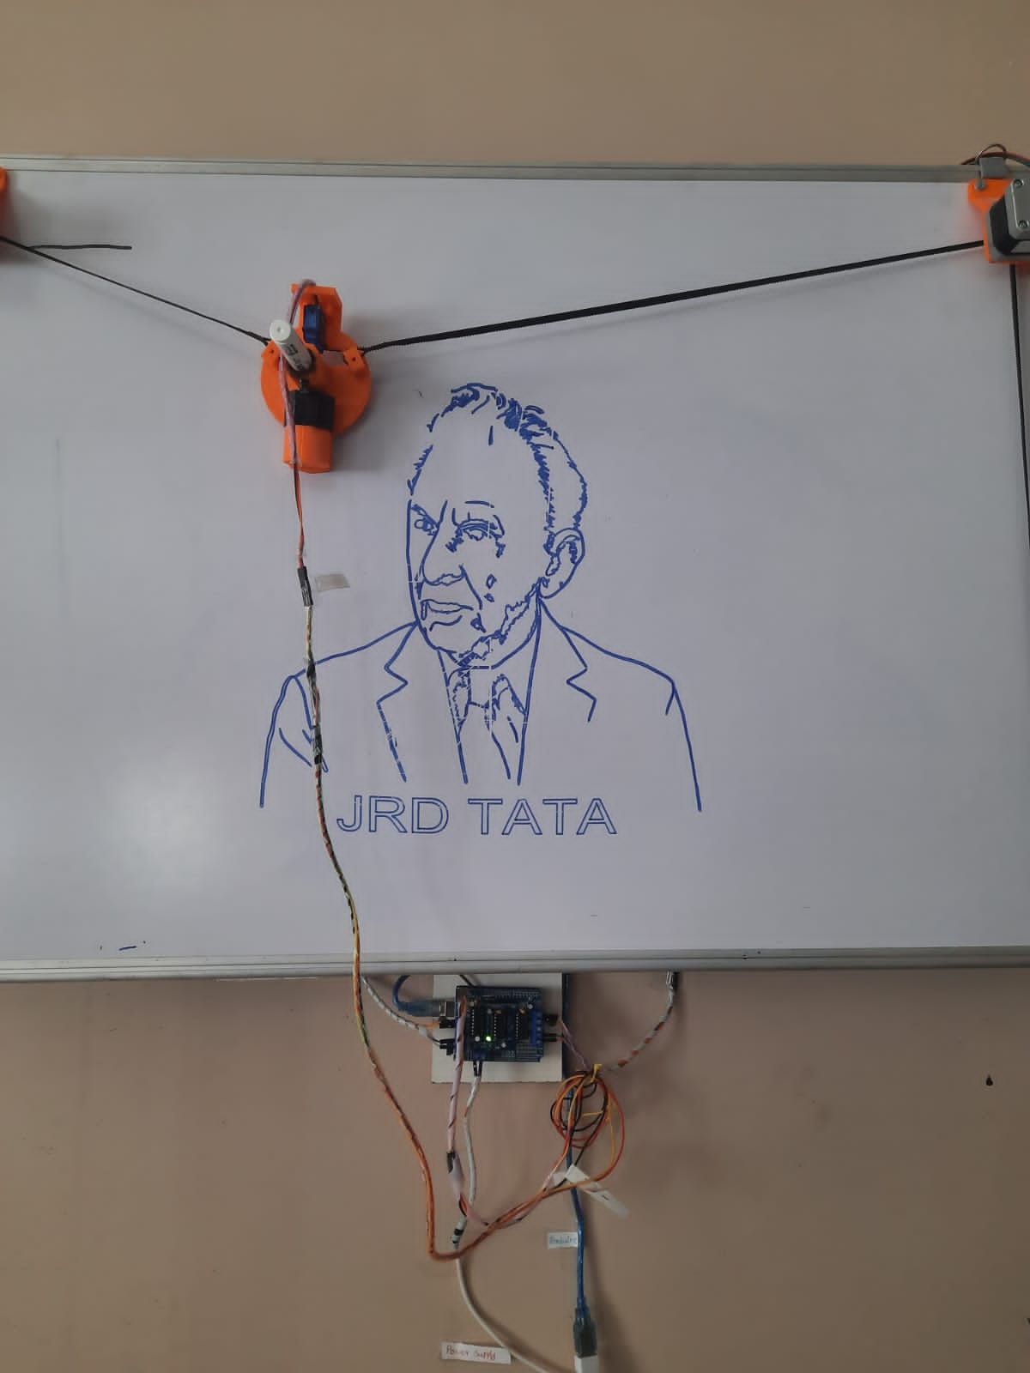

[Sketch C: Ganesha and JRD TATA]

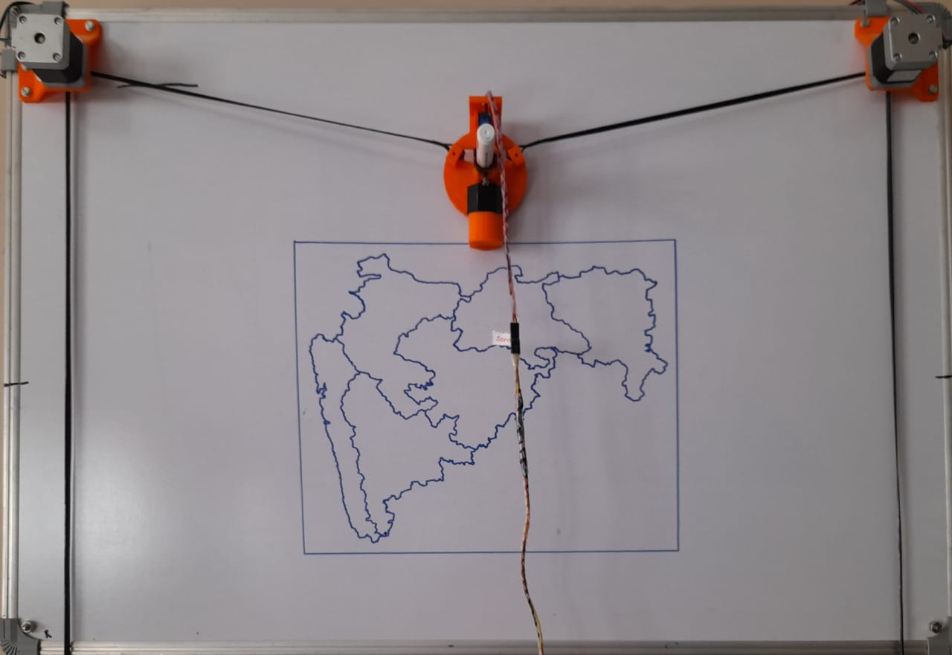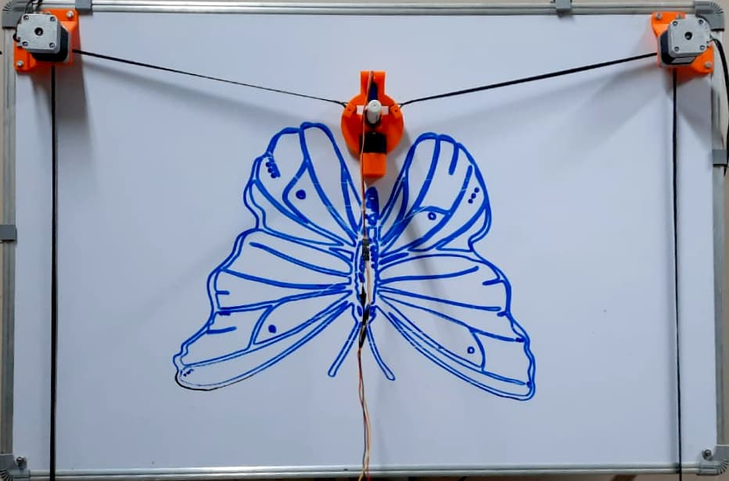

[Sketch D: Maharashtra Map and Butterfly]

**Chapter –4**

**Cost Estimation:**

|  |  |  |  |
| --- | --- | --- | --- |
| **SR.NO.** | **ITEM NAME** | **QTY.** | **COST (RS.)** |
| 1 | Arduino Board UNOR3 | 1 | 829 |
| 2 | L293D motor drive shield | 1 | 165 |
| 3 | NEMA 17 Stepper motor | 2 | 1526 |
| 4 | MG90S Servo motor | 1 | 599 |
| 5 | GT2 Rubber Belt (5 Meter) | 1 | 838 |
| 6 | GT2 16 Teeth Pulley | 2 | 290 |
| 7 | 3 IN1 Jumper Wire | 1 | 103 |
| 8 | White Board | 1 | 550 |
| 9 | 5V>2V Power Supply | 1 | 169 |
| 10 | L293D motor drive IC | 2 | 138 |
|  | TOTAL | | 5207 |

[Table I: Cost Estimation]

**Chapter –5**

**Possible Outcomes**

The outcomes we desiring from our project is are as follows:

1. Build robot for drawing different types of sketches of any size.
2. Portable robot which operates from anywhere.
3. Design and develop multipurpose robot which can be used for other work than sketching like laser cutting, wood cutting and for engraving operation.
4. The main focus is also it should be easy to operate.
5. Learn about the 3 D printing process and get hands on experience while printing the main components of the project.

**Chapter - 6**

**Concluding Remarks and Scope for the Future Work**

**6.1. Concluding Remarks**

1.The main reason to make the choice of designing a robot such that it is capable to draw sketch with required ratio sizes.

2. The main task was design machine which can be used in verities of application such as interior designing, logo printing, engraving, sketching, laser design cutting etc.

3.Our task is to overcome horizontal plotting machine which having limitations.

4. In this project work we have presented an efficient robot with unique abilities of drawing having low cost and financially feasible

5. We tried to cover all the aspects of design and structural analysis in our work. But there is still a large chance of upgrading the machine

6. This system would make it easier for human beings to make sketches on any vertical surface with any size ratio with any colour choice.

**6.2. Scope for the Future Work**

Although a good effort is put in building and analyzing this system, this cannot be taken for granted. There are many other parameters on which the quality of a model is dependent on. The easiest way to design and develop a sketching robot is described and explained in this document. We cannot say it is perfect. In fact, no design is perfect. It is all about how close you can get to perfection. This system should not only perform but also best but also it should be use. So, with the use of vacuum gripper, it can be fitted mount on the wall at any distance so by this method we can make it portable. There is always more room for innovation in any study. Also, instead of using a single pen, if color sketch has to draw then for that purpose it can be upgraded to multiple pen arrangement. During this project, we came across many modern innovative automation techniques.

Sketching robot have a wide scope of development. In the near future these sketching robot will be able to sketch as humans and in much better accuracy. This type of robot with different configuration available in the market, with the interest and technical expert, we can make it Bluetooth operated as well as IOT based robot which are the current modern technologies. Future-work can be done on the robustness of the project. By integrating all the components and assemble them all in the one cover will make it robust and portable. The communication from the Robot to Arduino can be implemented with different methods and using minimum programming. With all these additions, the machine gets upgraded into a super machine with ultimate application of automation.

**References**

|  |
| --- |
| **Problem statement given by the I Tech Robotics & Automation Pvt. Ltd**.  **Papers from Journal or Transactions:**  1. Sidharth Tripathi, Dev Joshi, Beauty sharma, “XY Plotter”, International Journal of Advances in Science Engineering and Technology, Volume-6, issue-4, Oct-2018  2. Mrs. R. Dayna, Gunaseelan P., “Microcontroller based X-Y plotter”,International Journal of Advanced Research in Electrical, Electronics and Instrumentation Engineering Volume.3, issue 3, Apr 2014.  3. Saurabh Sharma, Harish, S. B Nikam ,“X Y drawing robot using Arduino”, IJIRT, Volume 6 issue 2, July 2019  4. Rowjatul Zannat Eshita, Tanwy Barua , Arzon Barua Anik Mahamood Dip, “ Bluetooth Based Android Controlled Robot”American Journal of Engineering Research , Volume-5, Issue-3, 2016.  ***Textbook:***  Appu Kuttan K.K. , Robotics, I. K. International Publisher, Banglore ,Delhi, 1 oct 2013 |